AMDP CURD Operations:
AMDP (ABAP Managed Database Procedures) is a feature in SAP HANA that allows you to write database procedures in SQL Script directly within the ABAP environment. AMDP provides a seamless way to execute database-level operations from ABAP while leveraging the power of HANA's in-memory capabilities. When it comes to CRUD operations (Create, Read, Update, Delete), here's how they are typically handled with AMDP:
Why Use AMDP for CRUD Operations?
Performance: AMDPs run directly on the database layer, making them faster than traditional ABAP for complex operations.
Complex Scenarios:
AMDP can handle bulk data operations efficiently, such as processing thousands of orders in real time.
Seamless Integration:
AMDP allows developers to stay in the ABAP environment while leveraging HANA’s advanced database features like parallel processing.
Business Scenarios:
A manufacturing company wants to streamline its sales process to ensure accurate order fulfillment and improve customer satisfaction. The company uses AMDP in the SD module to handle the following tasks:
- Sales Order Creation: Automatically reserve stock or trigger purchase requisitions if stock is insufficient.
- Order Status Tracking: Provide real-time updates on sales order status.
- Delivery Management: Update the status of deliveries once completed.
Steps to achieve AMDP CURD Operations:
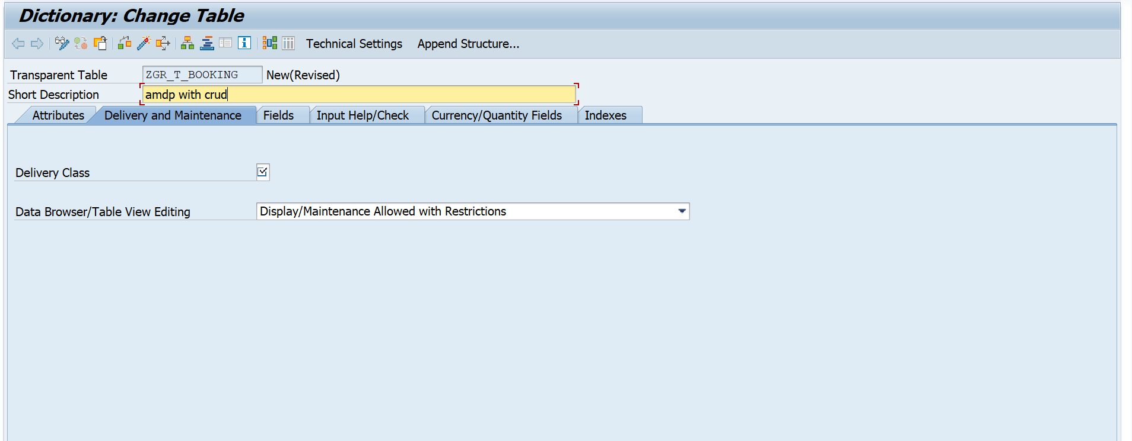

Give the fields in the table:
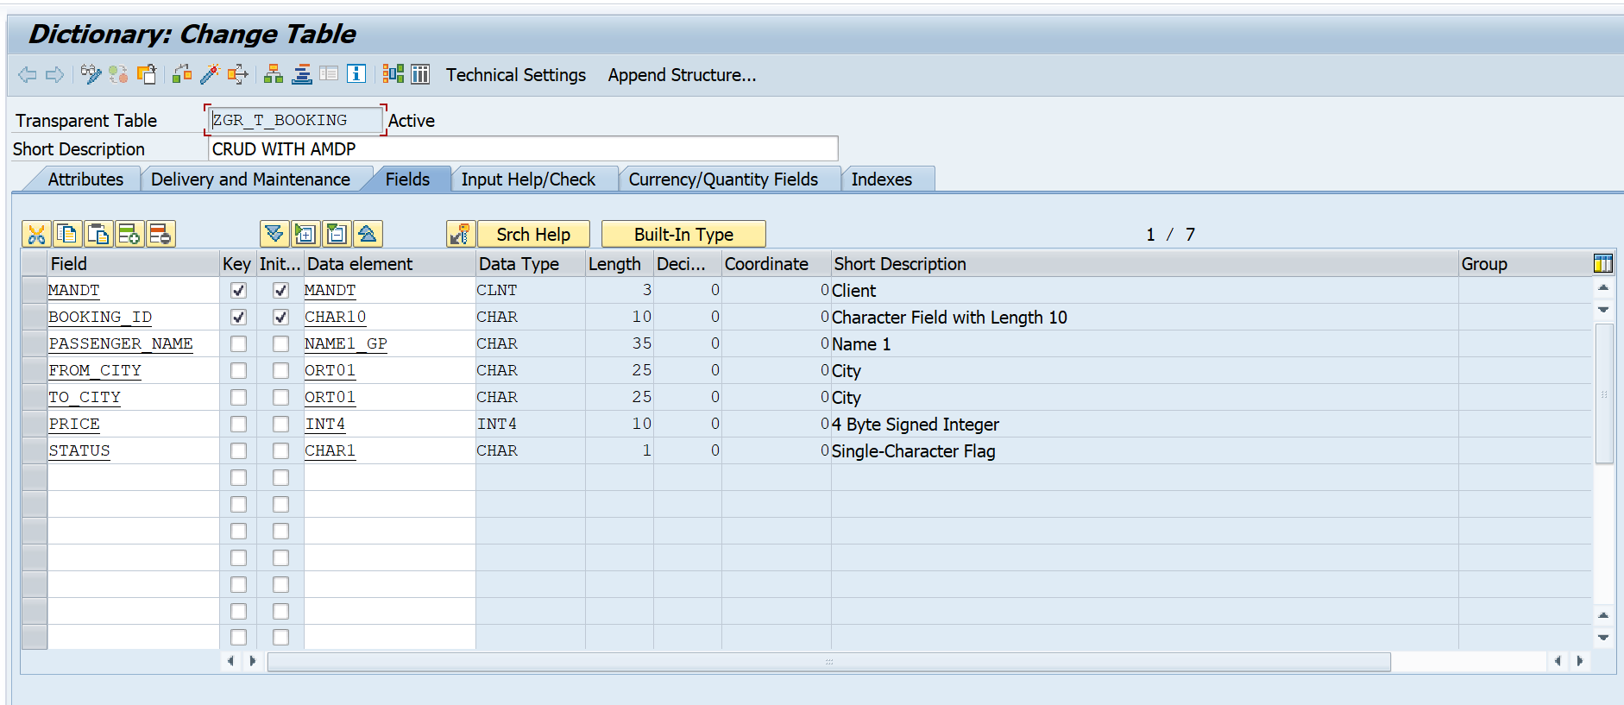

Create a class in the se24 and follow the below code :
class ZCL_DELOITTE_AMDP_CURD definition
public
final
create public .

PUBLIC SECTION.

TYPES: tt_booking TYPE TABLE OF zgr_t_booking.

INTERFACES if_amdp_marker_hdb.

CLASS-METHODS:
create_data,
update_data,
read_data EXPORTING VALUE(it_booking) TYPE tt_booking,
delete_data.

PROTECTED SECTION.
PRIVATE SECTION.
ENDCLASS.

CLASS ZCL_DELOITTE_AMDP_CURD IMPLEMENTATION.

METHOD create_data BY DATABASE PROCEDURE FOR HDB
LANGUAGE SQLSCRIPT
USING zgr_t_booking.

-- Include session_context('CLIENT') to pass the current MANDT automatically
it_insert_data = SELECT session_context('CLIENT') AS mandt,
'BID0000103' AS booking_id,
'RUSHITHA' AS passenger_name,
'KADAPA' AS from_city,
'BANGALORE' AS to_city,
100 AS price,
'' AS status
FROM dummy;

INSERT INTO zgr_t_booking SELECT * FROM :it_insert_data;

ENDMETHOD.

METHOD update_data BY DATABASE PROCEDURE FOR HDB
LANGUAGE SQLSCRIPT
USING zgr_t_booking.

UPDATE zgr_t_booking
SET passenger_name = 'RESHMA'
WHERE mandt = session_context('CLIENT')
AND booking_id = 'BID0000103';

ENDMETHOD.

METHOD read_data BY DATABASE PROCEDURE FOR HDB
LANGUAGE SQLSCRIPT
OPTIONS READ-ONLY
USING zgr_t_booking.

it_booking = SELECT mandt,
booking_id,
passenger_name,
from_city,
to_city,
price,
status
FROM zgr_t_booking
WHERE mandt = session_context('CLIENT');

ENDMETHOD.

METHOD delete_data BY DATABASE PROCEDURE FOR HDB
LANGUAGE SQLSCRIPT
USING zgr_t_booking.

DELETE FROM zgr_t_booking
WHERE mandt = session_context('CLIENT')
AND booking_id = 'BID0000103';

ENDMETHOD.

ENDCLASS.
Create a report program in the se38:
To test our amdp program.
*&---------------------------------------------------------------------*
*& Report ZTEST_AMDP_CRUD_TEST
*&---------------------------------------------------------------------*
*&
*&---------------------------------------------------------------------*
REPORT ZTEST_AMDP_CRUD_TEST.
DATA: lt_booking TYPE ZCL_DELOITTE_AMDP_CURD=>tt_booking.
START-OF-SELECTION.
" 1. Create Record
ZCL_DELOITTE_AMDP_CURD=>create_data( ).
WRITE: / '1. Record Created (BID0000103 - RUSHITHA)'.
" 2. Read and Display
ZCL_DELOITTE_AMDP_CURD=>read_data( IMPORTING it_booking = lt_booking ).
cl_demo_output=>display( lt_booking ).
" 3. Update Record
ZCL_DELOITTE_AMDP_CURD=>update_data( ).
WRITE: / '2. Record Updated (Name changed to RESHMA)'.
" 4. Read and Display Updated Result
ZCL_DELOITTE_AMDP_CURD=>read_data( IMPORTING it_booking = lt_booking ).
cl_demo_output=>display( lt_booking ).
" 5. Delete Record
ZCL_DELOITTE_AMDP_CURD=>delete_data( ).
WRITE: / '3. Record Deleted (BID0000103)'.

